Facts. No Filters. Campaign Post Copy

Internal Campaign Name: Facts. No Filters.
Language: English
Call to Action: MyLifeMyQuit.org
YouTube Links to Videos as reference: TBD

Ad Name/Version | “Vaping Harms” | Design
Primary Text  (80 characters ideal for FB; IG 60 characters) | Vaping is designed to get you hooked, no matter what the industry tells you. | For story ad, will need an intro image using this copy on the left.
Carousel Card #1 | Copy on image (if applicable):  The nicotine in vapes makes it hard to quit. | 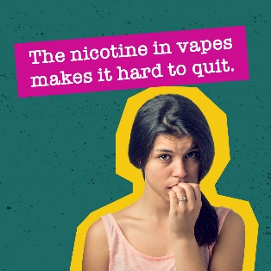
Headline  (20 characters) | Get the facts, visit MyLifeMyQuit.org
Description #1  (18 characters) | Dangers of vaping
Carousel Card #2 | Copy on image:  It’s not water vapor – it’s an aerosol filled with chemicals. | 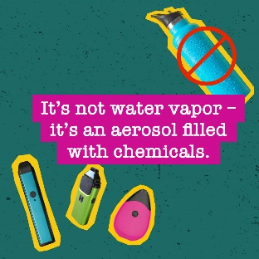
Headline #2  (20 characters) | Get the facts, visit MyLifeMyQuit.org
Description #2  (18 characters) | Dangers of vaping
Carousel Card #3 | Copy on image:  The nicotine in vapes can make your mental health worse. | 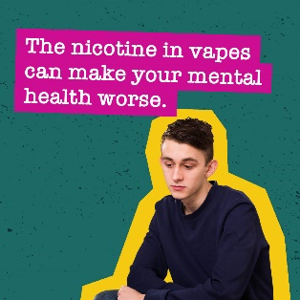
Headline #3  (20 characters) | Get the facts and get help to quit
Description #3  (18 characters) | Dangers of vaping
Carousel Card #4 | Copy on image:  Vaping can weaken your immune system. | 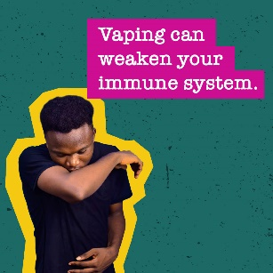
Headline #4  (20 characters) | Get the facts and get help to quit
Description #4  (18 characters) | Dangers of vaping
Carousel Card #5 | Copy on image:  Facts. No Filters. | 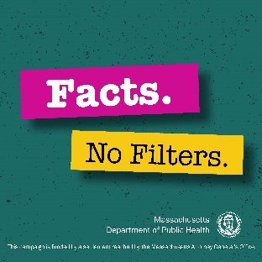
Headline #5  (20 characters) | Get the facts, visit MyLifeMyQuit.org
Description #5  (18 characters) | Dangers of vaping

Ad Name/Version | Support a Friend | Design
Primary Text  (80 characters ideal for FB; IG 60 characters) | Do you worry about friends who vape? Here’s how to help them start quitting. | For story ad, will need an intro image on this ad using this copy on the left.
Carousel Card #1 | Copy on image (if applicable):  Put yourself in their shoes.  Vaping is addictive and hard to quit! | 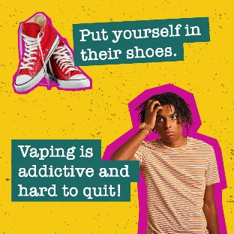
Headline  (20 characters) | Get the facts and get help to quit
Description #1  (18 characters) | Dangers of vaping
Carousel Card #2 | Copy on image:  Listen, don’t lecture.  Let them share without judgment. | 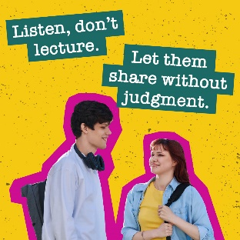
Headline #2  (20 characters) | Listen first
Description #2  (18 characters) | Vaping is addictive
Carousel Card #3 | Copy on image:  Be patient.  Your friend might not be ready to quit. | 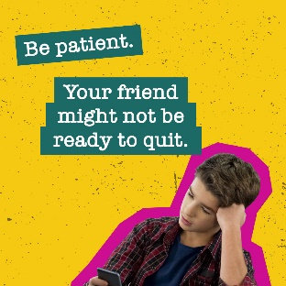
Headline #3  (20 characters) | Be a friend
Description #3  (18 characters) | Resources to quit
Carousel Card #4 | Copy on image:  Offer your support.  Share resources to quit. | 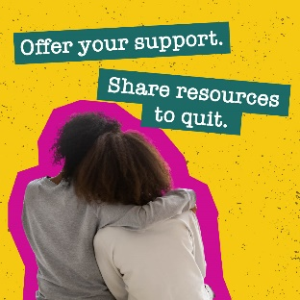
Headline #4  (20 characters) | It takes time
Description #4  (18 characters) | Resources to quit
Carousel Card #5 | Copy on image:  Facts. No Filters. | 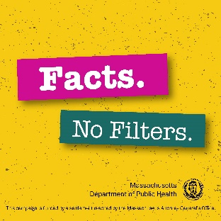
Headline #5  (20 characters) | Get the facts, visit MyLifeMyQuit.org
Description #5  (18 characters) | Resources to quit

NEW Two static newsfeed ads; static images for Instagram: 1080x1080
Ad Name/Version | “Mental Health” | Notes for Design
Primary Text  (80 characters ideal) | The nicotine in vapes can have a negative effect on your mental health.
Image  Vertical Story placements do not have accompanying text. The ad/image needs to include all necessary copy. | (image name/description/copy)  Think vaping reduces stress? Think again—nicotine can make your anxiety worse. | 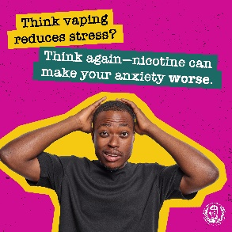
Headline  (20 characters ideal) | Get the facts, visit MyLifeMyQuit.org
Description  (18 characters max) | Dangers of vaping

Ad Name/Version | “Brain” | Notes for Design
Primary Text  (80 characters ideal) | The tobacco and vaping industries target youth – to make them customers for life.
Image  Vertical Story placements do not have accompanying text. The ad/image needs to include all necessary copy. | (image name/description/copy)  Your developing brain makes it easier to get addicted to nicotine from vaping. | 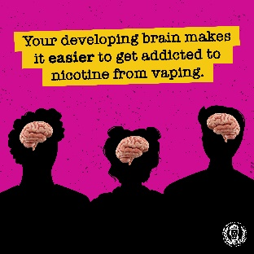
Headline  (20 characters ideal) | Get the facts and get help to quit
Description  (18 characters max) | Dangers of vaping

Instagram In Feed Videos and Reels
Asset Name | Anxiety
Primary Text | If you think vaping will help reduce stress or anxiety, think again. The nicotine in vapes may make anxiety worse.

Asset Name | Zombies
Primary Text | Your brain should be your business. Don’t let the vaping industry get a hold of your mind. Get the facts, no filters.

Asset Name | Give Up
Primary Text | Worried about a friend who vapes but not quite sure how to talk to them? Start here. Get the facts, no filters.

Asset Name | Bad Taste
Primary Text | You can’t taste them, but the harmful chemicals in vapes can still hurt you. Get the facts, no filters.

Asset Name | Mood
Primary Text | Your mental health matters. The nicotine in vapes can have a negative effect on your mood and wellbeing.

